**MDP Assessment Rules**

1. Note that the arena will be an open arena and **NO boundary boards will be kept.**
2. All teams taking part in the challenge for each week MUST place their Equipment (Laptop, Tablet and Robot) in the Quarantine area before the Arena Layout is released.
3. The sequence of the teams will be random.
4. Once a team is notified that it is their turn, they must take their equipment  
   from the Quarantine area and do their setup within **two minutes of the preparation time**.
5. For Automatic movement and automatic Image recognition (Task 1) and fastest car challenge (Task 2), apart from the first chance, one “RETRY” chance will be given.

For example, if your first attempt for Task 1 was not successful and if you take the “RETRY” chance for your Task 1, then the teams’ score will be based only on the “RETRY” run.

Do note that , if you opt for a “RETRY”, your first run will be void and the score is only based on RETRY

A team can have only one “RETRY” chance to be taken either in Task 1 or Task 2

Please note that those who are participating for the “RETRY” chance (for the same task) still must quarantine the equipment for the whole time (first and second run and time in between that) with no modification to the robot or algorithm settings.

**Task 1- Automatic movement and automatic image recognition**

1. Each team must ensure that the obstacle position and the images (given in the image list) are set-up according to the official layout given by the supervisors. Note that you are only asked to check the obstacle position based on the x, y coordinated indicated in arena. Hence there is no need of any physical measurement required.
2. If the challenge-run proceeds with the wrong image, facing and position, the team will NOT be given a second chance and the score will still be based on the official layout given by the supervisors.
3. During the 2 minute preparation time, the team will be given the information of the (x, y coordinates) of the obstacle and the face to which the image is attached. They can key in this information using their android tablet **in front of a supervisor.**
4. In order to qualify for **automatic movement and automatic image recognition**, the **robot MUST identify the (image ID of the image on the obstacle), update the image ID in real time(image ID should come on the obstacle) on the ANDROID tablet and STOP automatically by ITSELF within 6mins**.
5. If the team is unable to complete their preparation within the 2mins, they can still carry-on, but additional time incurred will be added to the automatic movement and image recognition task.
6. When the team is ready, they should inform their supervisor. After the supervisor has given the approval to start, the team can **Start (Press the corresponding button on the Android device). The teams should not touch any other equipment other than the start button of the android during the automatic movement and automatic image recognition run. After pressing the start button of the android tablet, it should be placed on a table such that supervisor can clearly see the real-time updates on the android tablet.**
7. During image recognition, the students should show the RAW image captured using Rpi Camera along with the bounding box for the image recognized on **either their Android device or PC Notebook** in a tiled manner (i.e. to display a **single representative image captured** **for each character recognized** during the run) and tile them all in one window. This page should **be accessible from the main page of Android display where Virtual map is displayed or be displayed on the PC screen after the run is over. Only character images that matches that listed in the image ID shown in android will be awarded points.**

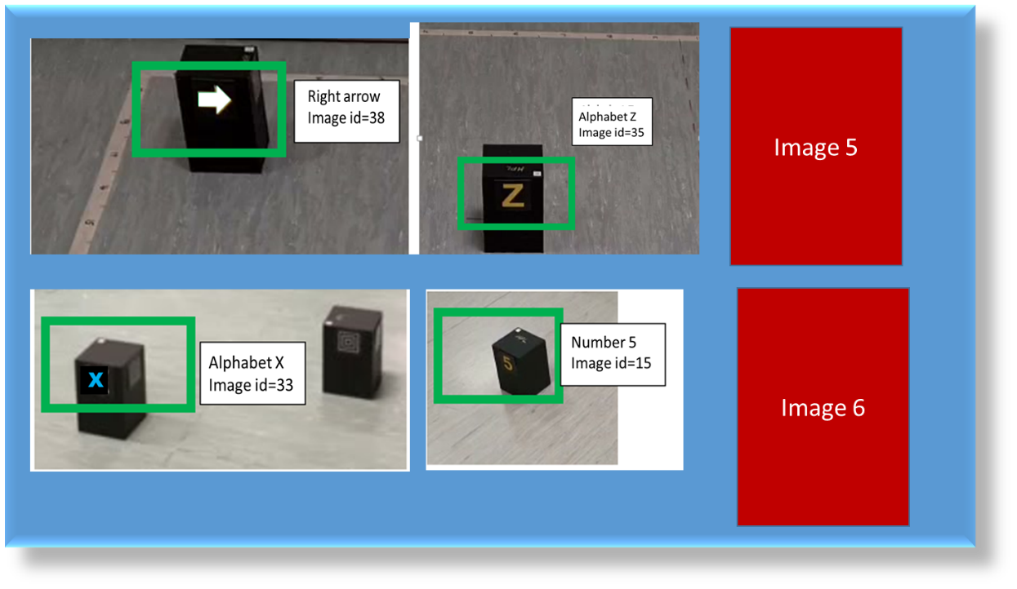

(RAW image means the image taken by camera which included the characters from the image list bounded by the bounding box and the background of the maze). An indicative screen shot is given above for your reference considering that we had 6 images kept on 6 different obstacles.

1. Those teams who chose to run the “RETRY” chance for Task 1, will **run their “RETRY” chance immediately after all teams have completed their first chance. Please note that those who are participating for the “RETRY” chance must quarantine the equipment for the whole time (first and second run and time in between that)** with no modification to the robot or algorithm settings. **The result taken will be from the “RETRY” chance if the team goes for “RETRY”. A new maze will be used for the second run.**
2. Supervisors will be checking the real time update of the image id displayed on the tablet throughout the run. Hence the result of individual image recognition should be updated on the android map immediately once the robot reaches in front of that image. Once the image processing is fully done, the students need to show their map displayed on the Android tablet with updated image IDs (image ID (given in the image list- attached)), on the obstacle. The score depends on the number of correctly identified images. Not able to show the image ID will render the results invalid.
3. The timing for automatic image recognition will end when the image IDs (of all the images recognized) are displayed on the screen of the Android device. To qualify for an image recognition score, the robot MUST stop by ITSELF (with no physical intervention) within the maximum allowed 6 minutes. If the robot doesn’t stop by ITSELF within maximum runtime, then the run is “incomplete”. This include scenario where robot has to be stopped manually. (Refer FAQ 15)
4. At the end of the Automatic image recognition task, it is the team’s responsibility to ensure that the Supervisor’s take a photo of the **Virtual Map with the image id shown**, on the **Android Tablet Screen. The screen comprising of all the RAW images taken by Rpi Camera is also needed either** from the **Android Tablet Screen or PC notebook**. At the end of the run, the team must e-mail the supervisor a copy of the **screen shot of Android with image ID displayed and the screen shot comprising of all the RAW images captured**.

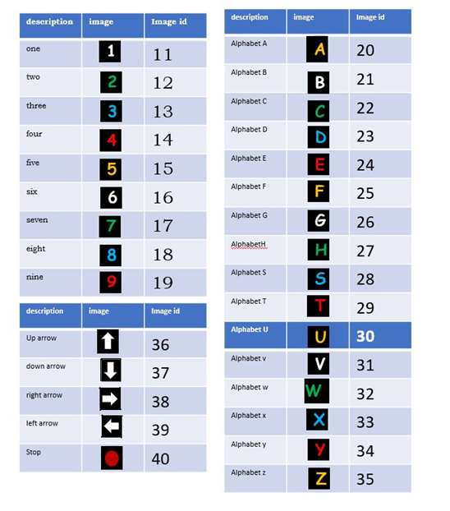

subset of 4 to 8

Images from 30 images available

**A sample arena is given below (the naming conventions will be given in a similar manner)**

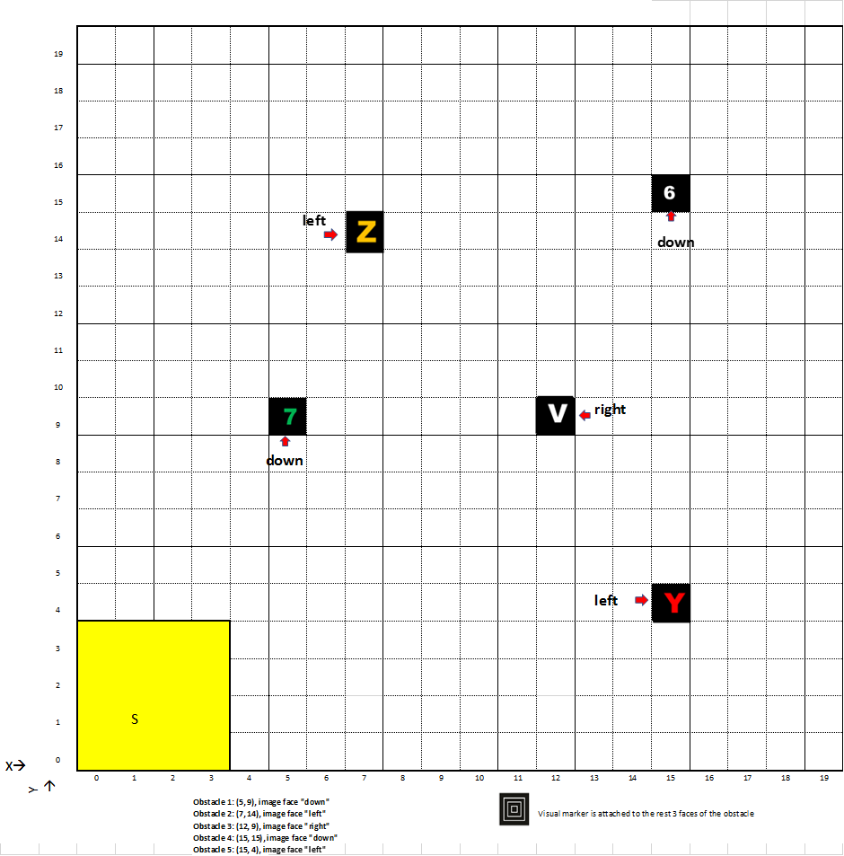

Obstacle 1: (5, 9), image face "down"

Obstacle 2: (7, 14), image face "left"

Obstacle 3: (12, 9), image face "right"

Obstacle 4: (15, 15), image face "down"

Obstacle 5: (15, 4), image face "left"

**Task 2- Fastest car task**

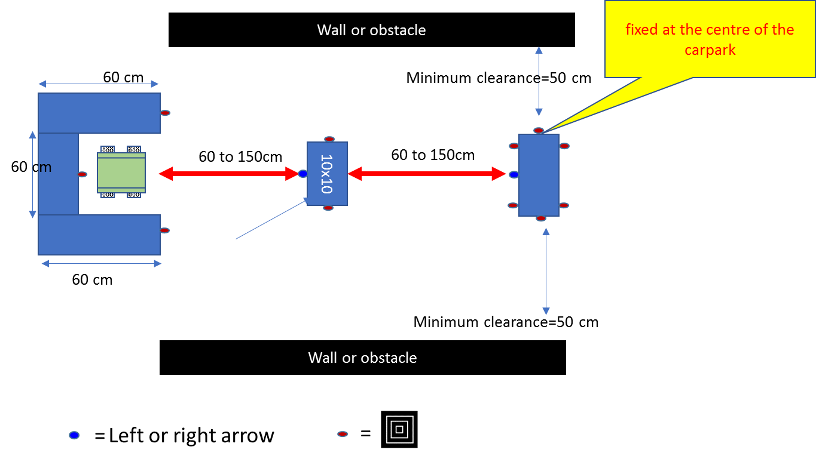

The general arena arrangement for the fastest car task is given above. The position of the bulls-eye images is indicated as small red ovals. The size of the carpark zone (60 cm X 50 cm: - inside dimensions) and the length and width of the obstacle 1 (i.e. closest to car park) is 10 cm x 10 cm as shown above. The dimension of obstacle 2 is only revealed just before the competition (after the preparation time). It has a width of 10cm. Its length can vary from a minimum of 30cm to a maximum that will still ensure that you still have a minimum clearance of 50cm on both sides (as shown above). Do note that there will be a clearance of 50 cm (minimum) given. The distance between carpark and obstacles is a variable and will be given only on the day of run. The car needs to move left or right of the obstacles according to the arrow images detected. These arrow images are affixed to the centre of the obstacles (as shown).

1. During the 2 min preparation time, the team allowed to check their bluetooth and Wi-Fi connection and can do a calibration (if needed) within the car parking zone. The robot must stay with the carpark zone during the preparation time.
2. Note that only after the preparation time, the supervisors will setup the obstacles and the images that you need to follow on the obstacles. This is to ensure that Students cannot measure the distance between carpark to obstacles and should not enter any information to their system regarding the same. Once the obstacles and images are set-up, then after supervisors approves, you can press the start button in your android.
3. In order to qualify for **fastest car challenge**, the **robot MUST run automatically from the carpark zone, move towards the each of the Goal obstacle, understand the image and act according to the image and come back to the same carpark that it started. It should also STOP automatically by ITSELF within the carpark zone**. The time limit for this task is **3 minutes.** If the robot sees a right arrow (), it should go around the right-hand side of the obstacle in front of it. If the robot sees a left arrow (), it should go around the left-hand side of that obstacle in front of it. The image will be attached to the mid-point of the obstacle and at the same height as that in the Task 1 challenge.
4. When the team is ready, they should inform their supervisor. After the supervisor has given the approval to start, the team can **Start (Press the corresponding button on the Android device). The teams should not touch any other equipment other than the start button of the android during the fastest car challenge run.**
5. If the team is unable to complete their preparation within the 2mins, they can still carry-on, but additional time incurred will be added to the fastest car challenge timing.
6. The timing for fastest car task will stop once the robot enters the CARPARK zone and STOPs. If the car hits the carpark wall, the run will be Disqualified.
7. If the team had not used their “RETRY” for Task 1, they can use it for Task 2, but it should be noted that, if a team goes for “RETRY”, then the score of the main run for Task 2 is invalid and the score will be based on the “RETRY”. The “RETRY” for fastest path will immediately follow the main run.
8. During image recognition, the students should show the RAW image captured using Rpi Camera along with the bounding box for the image recognized on **either their Android device or PC Notebook** in a tiled manner (i.e. to display a **single representative image captured** **for images on goal obstacles recognized** during the run) and tile them all in one window. This page should **be accessible from the main page of Android display where Virtual map is displayed or be displayed on the PC screen after the run is over. Only character images that matches will be awarded points.**
9. Each hit of obstacle during the fastest car task will be counted as a penalty (see FAQ 5 ,6 and 7)
10. At the end of the Fastest car challenge task, it is the team’s responsibility to ensure that the Supervisor’s take a photo of the **screen comprising of the RAW images taken by Rpi Camera either** from the **Android Tablet Screen or PC notebook**. At the end of the run, the team must e-mail the supervisor a copy of the **screen shot comprising of all the RAW images captured**.

**Frequently Asked Questions (FAQ)**

1. **When is my robot deemed to have reached the CARPARK zone?**  
   Once the entire robot is INSIDE the CARPARK zone.
2. **During the fastest car task, my robot moved out of CARPARK zone but didn’t go around the GOAL obstacle or come back to CARPARK zone. Does that qualify for fastest car task?**  
   No.
3. **How do we calculate the score for Automatic image recognition task (total 12.5%)?**

Each correct image ID on the correct obstacle in the virtual map is given 10 points.

1. **What if my robot gives wrong ID for the image recognized?**

Each wrong Image ID is given a **penalty of 10 points.**

1. **During the Fastest car task, my robot hit the obstacles on the way. How will the penalty be computed?**  
   Each new/distinct hit will add 10s penalty to the Fastest-car task timing.
2. **During the Fastest car task, my robot hits the sides of the carpark. Is that a penalty or a disqualification?**  
    If the car hits the carpark wall, the run will be Disqualified.
3. **What is meant by each distinct Hit/Contact with Obstacle?**  
   It refers to any NEW move that is made while still having contact with an obstacle  
   E.g. The robot touches and obstacle and stops. -> 10s Penalty  
   The robot continues to turn left/right while maintaining contact with the obstacle/wall.  
   -> 10s Penalty for each turn as long as contact is maintained.  
   NOTE THAT BULL DOZING OF AN OBSTACLE IS NOT PERMITTED
4. **What if my team can’t complete the preparation within time limit?**  
   You can still proceed. You will start making use of your image recognition/ fastest car task time if your preparation exceeds 2 min.

For e.g., if you take 3mins to complete the preparation, then you have 5mins left to complete the automatic image recognition.

1. **What if my robot moves beyond the CARPARK zone while performing the calibration during the preparation time?**  
   Once your robot moves beyond the CARPARK zone during the preparation time, you will be automatically **DISQUALIFIED** from that run.
2. **What if my robot detects a wrong image/ or makes a wrong turn with respect to the image given for Task 2?**  
   You will be automatically **DISQUALIFIED** from that run.
3. **Can my robot Bull-Doze through the obstacles for my fastest car task?**  
   Bull-Dozing is STRICTLY not allowed. Any team that attempts it will be disqualified.
4. **My team successfully completed the Image recognition the virtual map on the Laptop and not on the Tablet. Will it be accepted?**  
   In such cases, the team’s image recognition WILL **NOT** be accepted and they will NOT qualify for Image recognition task.
5. **My team was able to show the real-time update of the virtual map only on the laptop and not the android device. Will the image recognition be accepted?**

They will NOT qualify for image recognition.

1. **Will teams with the same image recognition score be given the same marks?**  
   We will use the image recognition timing to differentiate teams with the same image recognition score.
2. **Our robot was not able to stop by ITSELF during Task 1 automatic image recognition leaderboard, will we be disqualified?**

You can stop them manually. If you stop the robot manually, your team’s run will be marked as incomplete and the position of your team in leaderboard will be below all the teams who have completed the task by automatically stopping the robot (without physical intervention).

1. **Can we qualify for Task 1 and Task 2 task if we are not able to show the RAW image either on android tablet or on PC notebook at the end of the run?**

No, you are not qualified without displaying the RAW images **o**n android tablet or on PC notebookat the end of your Run.

1. **Can our team use “RETRY” chance twice?**

No, you are not allowed to use the “RETRY” chance twice. You can only use it once. If you use it twice, both the image recognition result and the fastest car task result will be considered invalid.

1. **Our team has some disagreements with our lab supervisors with certain aspects of our competition run. Who can we approach?**  
   Please approach the MDP coordinators to review your case. It will be good to provide any form of evidence such as video recordings. The coordinators will review the case with all available information.

**MDP Coordinator’s Decision is FINAL!**